Gary Hamel
1954-
Wikipedia:
The Wall Street Journal in 2008 has ranked Gary Hamel as one of the world's most influential business thinkers, and Fortune magazine has called
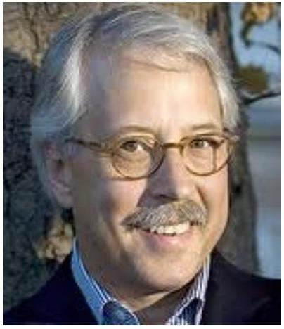
him "the world's leading expert on business strategy". Gary Hamel is the originator (with C. K. Prahalad) of the concept of core competencies. Although he is known as a "strategy" guru, most of his recent thinking is really about management.
Rediff 2005 Interview:
Hamel's interest in management theory stems from his raw years as a doctoral student at the University of Michigan. This was in the late 1970s, a time when the US auto industry was being hammered by new competitors. "I saw neighbors who lost their jobs, families who lost a bread winner, and people forced to sell their homes and so on. . . that's when I really understood the human consequences of poor management, that management is not some abstract concept, that it's not measured in the P&L statement. I learned to have a very healthy skepticism about the value of perceived wisdom, because the CEOs, these Gods, had been in the auto industry for 40 years. The red carpet was always out for them. They were constantly flying around in their airplanes. And yet people were losing their jobs."
From 'core competency' to 'resilience', tell us about your new work. What do companies have to do to
survive our turbulent times?
Any organization that hopes to become resilient must address four challenges: cognitive, strategic, political and ideological. To meet the cognitive challenge, a company must be conscious of what's changing and be continuously free of denial, nostalgia and arrogance. In terms of the political challenge, the organization must be able to divert resources from yesterday's products to tomorrow's. The ideological challenge is perhaps the most difficult of all - few organizations question the doctrine of optimization, but optimizing a near irrelevant business model can't secure a company's future. Renewal has to become continuous and opportunity driven rather than episodic and crisis driven.
How do you meet the cognitive challenge?
Every business is successful until it's not. What's amazing is how often top management is surprised when 'not' happens. Often even unexpected shocks can be anticipated -- if one pays close attention. Meeting the cognitive challenge means conquering denial. And that means three things. First, senior managers must make a habit of visiting the places where change happens first. Second, filter out the filterers. There will be people in your organization who understand what's changing and its consequences. Find them. Also find and remove the censors, the custodians of convention. Talk to potential customers who aren't buying from you. Create a shadow executive committee whose members are twenty years younger than the 'real' executive committee. Third, recognize the inevitability of strategy decay.
How do you meet the strategic challenge?
By valuing variety. The arithmetic is clear: if the range of strategic alternatives being explored by your company is significantly narrower than the breadth of change in its environment, your company is going to be a victim of turbulence. You need to experiment with innovation.
Most companies would be better off steering clear of grand imperial strategies and instead devoting energy to fostering lots of low risk experiments or startlets. Our experience suggests that a large company or business unit -- say between $\$5$ billion and $\$10$ billion in revenues should generate a minimum of 100 ground breaking stratlets every year, with each one absorbing between $\$10,000$ to $\$20,000$ in first stage investment.
And the political challenge?
In most organizations, a manager's power correlates directly with the resources he or she controls. Hence managers typically resist any attempt to reallocate 'their' capital and talent to new initiatives. Yet resilience demands resources to support a broad array of experiments. A persistent failure to distinguish between new ideas and risky ideas reinforces the tendency to overinvest in the past.
How should managers meet the ideological challenge?
The modern corporation is a shrine to a single 100-year-old ideal: optimization. The goal is do more, better, faster, cheaper. This ideology and its elaboration into values, metrics and processes has created enormous material wealth. But it is no longer enough. McDonald's has a famous slogan: billions served. But what happens when billions want something different?
Optimization becomes inadequate. Resilience can come only from embracing paradox.
In struggling to embrace the paradox between the relentless pursuit of efficiency and the restless exploration of new strategic options, managers can learn something from constitutional democracies and how countries such as America manage the paradox of unity and diversity.
The big mistakes a company makes are almost never because some lower level employee had a crazy idea and did something. The biggest mistakes are made by the people at the top.

